**CBCT Scan Request Form**

Patient details:

Title: First name: Last name:

Address:

Postcode: D.O.B

Tel (h): Tel (w): Mobile:

Email: Preferred contact method:

**Referring Dentist details**: *N.B. Please complete al fields*

Dentist name: Practice:

Practice address:

Postcode: Practice tel:

Email:

Brief patient history:

Reason for scan:

**CBCT scan requirements:**

All scans will be parallel to the occlusal plane unless otherwise specified. Radio-opaque to be worn? Yes  No

Field of view: **CBCT** **Scan Charges**:

Small Field (50X50mm) £103.00

Full Upper (80X50mm) £242.00

Full Lower (80X50mm) £242.00

Dual Jaw (80X90mm) £330.00

Sectional (80x50mm) Please mark area(s) on diagram below

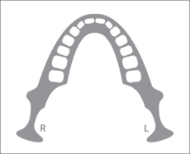 Dentist Signature:

GDC Number:  
STANDARD IMAGE RESOLUTION WILL BE SUPPLIED UNLESS YOU SPECIFICALLY REQUEST HIGH RESOLUTION OR ENDO (80X50mm FOV only)

Reports: Indicate your preference for radiological interpretation of the dento-alveolar region:

I undertake to report on the scan required by IR(ME)R 2000/2006

Assistance with planning: Assistance with case planning at Vitality Dental Care: Price on application.

YOUR PATIENT WILL BE ASKED TO PAY FOR THEIR SCAN AT THEIR APPOINTMENT.